Ciright Enterprise Cloud Platform

Sanni Thakor: 240160510052

MCA Sem – 4: Project Report prepared as a part of Syllabus 401
Year – 2025-2026

Internal Guide
Dr. Kamalesh Salunke
Professor of Computer Science
Department
Gujarat Vidyapith, Ahmedabad- 380 009
External Guide



Computer Science Department Faculty of Management and technology Gujarat Vidyapith, Ahmedabad – 380 009

Acknowledgement :

As part of the MCA (Semester 4) curriculum of MCA at the department of computer science, Gujarat Vidyapith, we have developed a project titled "Spiritual Portal."

I extend my heartfelt gratitude to the Head of the Department, Prof. Ajay Parikh, Prof. Dhiren Patel, Dr. Neepa Shah, Shree Kamlesh Salunke,
Dr. Ruchita Shah and all the staff. Their mentorship allowed me to learn a great deal, and I am sincerely thankful for the precious time they dedicated to me.

I would also like to thank the staff of Perception Care Pvt. Ltd , who provided me with valuable guidance throughout this project and helped me to provide resources to complete this project and take grateful experience.

Finally, I thank everyone who, knowingly or unknowingly, helped me.
- Table

Name | Page No.
1. About Gujarat Vidyapith | 1
2. About Company | 2
CHAPTER 1: INTRODUCTION
1.1 Background | 4
1.2 Objectives | 5
1.3 Purpose, Scope, and Applicability | 6
1.3.1 Purpose | 6
1.3.2 Scope | 7
1.3.3 Applicability | 9
CHAPTER 2: REQUIREMENT AND ANALYSIS
2.1 Problem Definition | 10
2.2 Requirements Specification | 11
2.3 Planning and Scheduling | 12
2.4 Software-Hardware Requirements | 13
2.4.1 Development Environment | 13
2.4.2 Implementation Environment | 14
2.5 Conceptual Model | 15
2.6 Data Flow Diagram | 16-22

2.7 E-R Duagram | 23
2.8 Object Oriented Diagram | 24-28
2.9 Activity Diagram | 29-33
CHAPTER 3: SYSTEM DESIGN
3.1 Basic Modules | 34
3.2 Data Design (Data Dictionary) | 35-40
3.3 User Interface Design | 41-59
CHAPTER 4: CONCLUSION
4.1 Conclusion | 61
4.2 Limitation of the System | 62
4.3 Future Scope of the System | 63
REFERENCES | 64

- About Gujarat Vidyapith

Gujarat Vidyapith is a university located in Ahmedabad, Gujarat, India. It was founded in 1920 by Mahatma Gandhi, the leader of the Indian independence movement, and granted deemed university status in 1963. Gujarat Vidyapith is founded by the U. G. C. (University Grants Commission) for higher education programs. It was started as Rastriya Vidyapith (National Institute of University Education) and was the wake of the Non-cooperative Movement. Mahatma Gandhi remained its life- long Kulpati (Chancellor).
The main objective is to prepare workers of character, ability, culture and dedication for the conduct of movements connected with the regeneration of country in accordance with the ideals given by Mahatma Gandhi. The guiding principles on which the integrated system of education, from Nursery & Basic Schools to Higher Secondary and from Bachelors to Master, M. Phil. & Doctorate level degree in various disciplines, is evolved include Adherence to truth and non-violence, Participation in productive work with a sense of dignity of labour, Acceptance of equality of religions Priority for the need of villages dwellers in all curricula and Use of mother-tongue as a medium of instructions.
Accordingly, the education system of Gujarat Vidyapith include regular participation in community work, residential life, social service, community prayers, simple and self reliant living, study tours and field studies, Hand spinning and training in Craft Work. The program of education has been linked with the national needs of rural uplift with a view to promote education conductive to the grass - root levels of the society. The chief concern of the Gujarat Vidyapith is to conduct experiments in various fields of education with a view to develop the application of Gandhian thought and way in all aspects of education.
- About Company:

Ciright Enterprise Pvt. Ltd., located in Ahmedabad, Gujarat, is a leading enterprise software and cloud solutions company specializing in advanced business automation platforms. The company provides innovative SaaS (Software as a Service) and PaaS (Platform as a Service) solutions to help organizations streamline their operations, improve efficiency, and enable digital transformation.
With a strong presence in both India and international markets, Ciright focuses on delivering scalable and secure enterprise applications that integrate multiple business functions into a single platform. The company is known for its robust Ciright Core Platform, which combines CRM, ERP, workflow automation, and AI-driven capabilities.
Ciright specializes in a wide range of services including:
    - Enterprise Software Development
    - Cloud-Based SaaS & PaaS Solutions
    - CRM (Customer Relationship Management) Systems
    - ERP (Enterprise Resource Planning) Solutions
    - Workflow Automation and Task Management
    - AI Integration and Smart Analytics
    - IoT (Internet of Things) Solutions
    - Custom Business Application Development

  - Website: https://ciright.com/
  - Portal: https://myciright.com/Ciright/login.htm
  - Address: Shivalik Shilp 2, 702 703, Judges Bunglow Rd, Suryapooja Block B, Satellite, Ahmedabad, Gujarat 380015
CHAPTER 1: INTRODUCTION

The Ciright Enterprise Platform is designed to transform traditional business operations by providing a fully digital, centralized, and cloud-based system for managing organizational processes such as customer relationships, tasks, contracts, and domain data.
It integrates multiple business functions like CRM, ERP, workflow management, and domain management into a single platform, enabling organizations to streamline their operations and improve efficiency. The system provides real-time data access, activity tracking, and automation, helping businesses make faster and more informed decisions.
The platform is highly scalable and can support multiple users, departments, and organizations, making it suitable for both small and large enterprises. It eliminates the dependency on manual processes such as spreadsheets and disconnected tools by offering a unified and structured system.
Ciright empowers different user roles such as Admins, Managers, Employees, and Customers to operate efficiently with role-based access control. Admins can manage system configurations and users, managers can monitor operations, employees can perform tasks and update data, and customers can interact with services seamlessly.
The system is developed using modern enterprise technologies such as Java, Spring MVC, Hibernate, JSP, and MySQL, ensuring a robust backend and user-friendly interface. By integrating automation and cloud capabilities, Ciright helps organizations achieve digital transformation, improved productivity, and scalable growth.
Background :

Existing business systems often operate separately, making it difficult to manage customer data, tasks, and workflows efficiently. Many organizations still rely on manual methods like spreadsheets and emails, leading to errors, delays, and lack of real-time visibility.
Most platforms do not provide proper integration, customization, or role-based access required for enterprise-level operations. Managing multiple modules such as CRM, ERP, and domain data across different systems becomes complex and inefficient.
There is a need for a centralized and scalable platform that supports integrated business processes, role-based access, real-time tracking, and workflow automation.
The Ciright platform addresses these challenges by providing a unified enterprise solution that streamlines business operations and improves efficiency.
  - : Objective :-

Scalable Platform
The Ciright platform is designed to support multiple organizations and scale efficiently as business operations grow.

Centralized Business Management
To provide a unified system where CRM, ERP, contracts, and task management are integrated into a single platform.

Improved Accessibility
Enable users to access the system anytime and from anywhere through a secure cloud-based environment.

Structured Workflow Automation
To streamline business processes by automating tasks, approvals, and workflows across departments.

Enhanced User Interaction
Provide real-time data visibility, activity tracking, and user-friendly interfaces for better decision-making.

Role-Based Access Control
Support multiple user roles (Admin, Manager, Employee, Customer) with defined permissions and secure access.

Custom Module Development
Allow flexibility to develop and integrate new modules such as Customer Contact enhancements and Domain Management.

Performance & Growth Ready
Ensure the system can handle increasing data, users, and business complexity without performance issues.

Digital Transformation
Help organizations move from manual processes to a fully digital, automated, and efficient business environment.
  - : Purpose ,Scope and Applicability :

    - Purpose :

The purpose of the Ciright platform is to transform traditional business operations by providing a centralized, cloud-based enterprise solution that integrates multiple business functions into a single system.
The platform aims to eliminate challenges such as data silos, manual processes, and lack of real-time visibility by enabling seamless management of customers, tasks, contracts, and workflows.
It empowers organizations to improve efficiency, enhance decision-making, and automate routine operations through advanced technologies such as cloud computing and AI.
Ultimately, the goal is to support organizations in achieving digital transformation, operational excellence, and scalable growth.
    - Scope:

In-Scope Activities
  - User Role Management
- Role-based access for Admin, Manager, Employee, and Customer
- Secure authentication and authorization mechanisms
- Role-specific dashboards and data visibility

Web Application Development
- Cloud-based web application using enterprise technologies (Java, Spring MVC, JSP)
- Compatible with modern browsers and responsive UI design

Customer & Contact Management (CRM)
- Manage customer and contact information
- Enhancement of customer contact fields (e.g., Middle Initial)
- Relationship tracking and data organization

UI/UX Enhancements
- Improved visibility of project names and headers using CSS modifications
- Clean and user-friendly interface for better usability

Domain Management Module (E-Domains)
- Creation of a new module under Customer section
- Display and manage domain data in ascending order
- Database design and implementation (tbl_domains)
- Support for domain attributes such as suffix, IP address, and registry manager

Workflow & Task Management
- Task creation, assignment, and tracking
- Automated workflows based on system triggers and events

Database Implementation
- MySQL-based data storage
- Efficient table design with primary and foreign key relationships
- Optimized queries for performance

Module Development & Integration
- Full-stack implementation including Entity, Model, Service, Controller, JSP, JavaScript, and DWR
- Seamless integration of new modules into existing system

Activity Tracking & Data Management
- Real-time data updates across modules
- Tracking of user activities and system changes

Chap : 2 Requirement and Analysis :

  - Problem Defination :

    - The current business environment often relies on disconnected systems and manual processes such as spreadsheets, emails, and standalone applications to manage customers, tasks, and operational workflows. This leads to inefficiencies, data duplication, and lack of real-time visibility.
    - Existing platforms do not provide proper integration between CRM, ERP, workflow management, and domain data, making it difficult for organizations to manage their operations in a centralized manner. Additionally, limited customization and lack of flexible module development restrict businesses from adapting systems according to their specific needs.
    - There is also a challenge in maintaining role-based access control, where different users (such as admins, managers, and employees) require different levels of permissions and data visibility. Without a structured system, managing user roles and responsibilities becomes complex and error-prone.
    - Furthermore, tracking customer interactions, managing domain information, and ensuring seamless communication across departments becomes difficult when data is spread across multiple systems.
    - Therefore, there is a need for a centralized, scalable, and customizable enterprise platform that integrates all core business functions, provides role-based access, supports real-time data management, and enables workflow automation.
    - The Ciright platform addresses these challenges by offering a unified system that improves operational efficiency, enhances data management, and supports business growth through digital transformation.
2.2-Requirement and Specification :

Functional Requirements

Admin
- Manage all users including employees, customers, and system roles
- Control platform configurations and access permissions
- Monitor system activities and workflows
- View and manage all modules (CRM, ERP, Work, Contracts, Domains)
- Access analytics and reports related to business operations
- Ensure data security and role-based access control

Manager / Vendor-Level User
- Manage teams, customers, and business data
- Approve or manage operational workflows and tasks
- Monitor performance, activities, and reports
- Handle module-level operations such as customer and domain management
- View engagement and activity data across projects

Organization / Department
- Manage internal users (employees/team members)
- Assign tasks, roles, and responsibilities
- Monitor progress and performance of teams
- Manage customer data and business operations
- Track activity and workflow execution

Employee / User
- Manage assigned tasks and responsibilities
- Create and update business data (customer contacts, domains, etc.)
- Participate in workflows and system processes
- Track assigned work and progress
- Interact with system modules based on role permissions

Customer / End User
- Access assigned data and services
- View relevant information (contracts, services, interactions)
- Engage with the system based on permissions
- Track interactions and updates related to services

Non Functional requirement:

  - Performance Requirements
  - The system must efficiently handle multiple concurrent users and large volumes of data without affecting performance. It should ensure fast response time and smooth execution of operations across all modules.

Security Requirements
  - The system must implement role-based access control (RBAC) to ensure users can only access features relevant to their roles (Admin, Manager, Employee, Customer).
It must prevent unauthorized access and ensure secure handling of sensitive business data.

Usability Requirements
  - The platform should provide a clean, intuitive, and user-friendly interface for all types of users.
It must be easy to navigate and optimized for efficient usage across different business modules.

Availability
  - The system must be accessible through all major web browsers such as Chrome, Firefox, Safari, and Edge.
Being a cloud-based platform, it should be available anytime and from any location with internet access.

Maintainability
  - The system should be built using a modular and scalable architecture that supports easy debugging, testing, and maintenance.
It should allow seamless upgrades and integration of new features without affecting existing functionalities.
  - Hardware and Software Requirements

Development Environment

Hardware:

Processor | intel corei7 8th Gen
Storage | 256 GB
RAM | 16 GB

Software Requirements:

Operating System | Window11
Frontend | Reactjs
Backend | Node JS
IDE | VS Code
Dastabase | MongoDb
Development Tools | PostMan

Implementation Environment

Hardware:

Processor | Intel core i7
Storage | 256 GB
RAM | 16 GB

Software Requirements:

Operating System | Window11
Frontend | JSP, HTML, CSS, JavaScript
Backend | Java, Spring MVC, Hibernate
IDE | Eclipse
Dastabase | MYSQL
Development Tools | Postman, Git, MySQL Workbench

%

Data Flow Diagram :

  - Context-level Diagram :
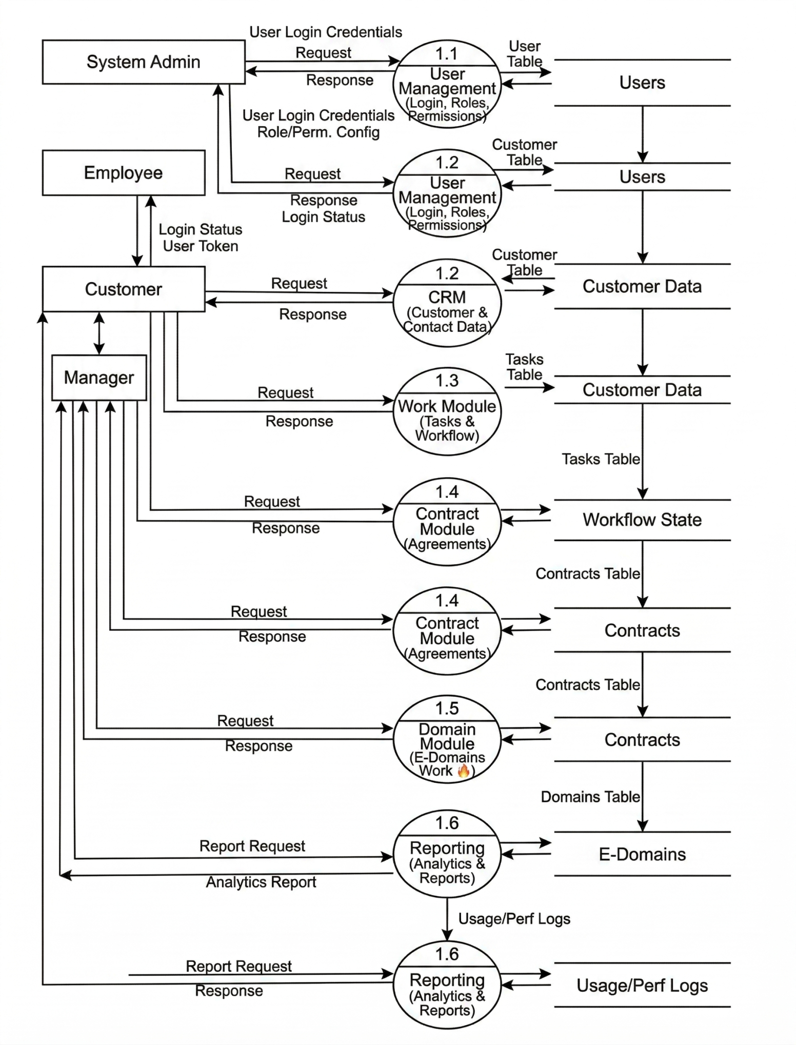

  - Zero-Level daigram:

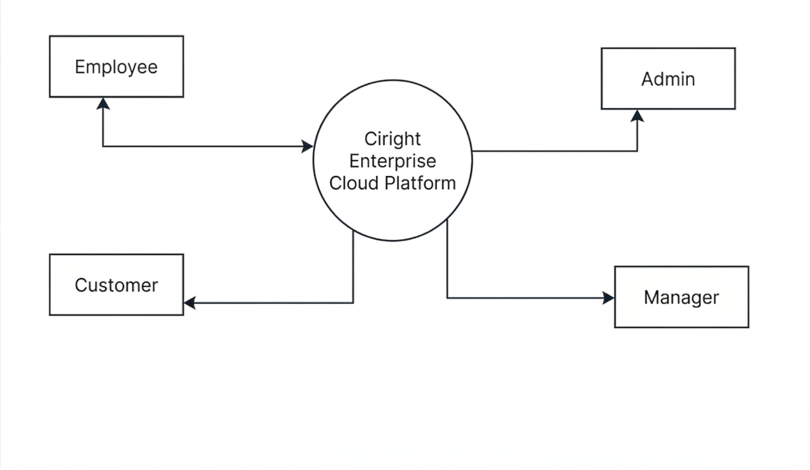
System Flow

- E-R daigram:
4.Object Oriented Diagram (UML):
A.USECASE :

- Admin:

B.Activity Diagrams(UML):

Admin:

CHAPTER 3: SYSTEM DESIGN
  - Data Design (Data

    - Unauthorized Access : Without proper Role-Based Access Control (RBAC), users might access modules not meant for them.
    - Weak Authentication: Poor password policies or lack of 2FA could lead to account breaches.
    - Data Leakage : Sensitive data (student records, certificates, etc.) could be exposed if not encrypted or securely stored.
    - Insufficient Input Validation: Could lead to SQL injection, cross- site scripting (XSS) , or other code injection attacks. .
    - Insecure APIs: Unprotected or poorly secured backend APIs could be exploited to access or manipulate data.
    - File Upload Vulnerabilities: Teachers uploading materials might unknowingly upload malicious files if validation is weak.
CHAPTER 4: CONCLUSION

  - Conclusion :

The proposed Learning Management System (LMS) provides a scalable, secure, and user-friendly platform tailored for multi-entity educational ecosystems including Super Admin, Vendors, Colleges, Teachers, and Students.
This system can independently manage courses, monitor performance, and enhance the learning experience. With built-in tools for real-time engagement, role-based access, and self-paced learning, the system promotes digital empowerment and bridges the gap between traditional and modern education methods. It lays a solid foundation for future scalability, security, and academic excellence across partnered institutions.
  - Limitation of the System:

No Offline Support:
Users must have internet access; offline access to content is not available.

Manual MOU Process:
Vendor-college agreements (MOUs) are handled offline, not integrated into the system.

Initial User Limitations:
Supports up to 1000 concurrent users; scalability beyond this needs future optimization.

Content Quality Depends on Teachers :
The effectiveness of courses relies on how well teachers create and manage their content.

No Multi-Language Support:
At launch, the system supports only one language (e.g., English), limiting accessibility.
  - Future Scope of the System

Student Progress Reports (Downloadable PDFs) :
Allow teachers and admins to generate downloadable progress and performance reports for each student.

Feedback & Rating System :
Students can rate courses and give feedback, helping improve content quality.

Live Class Recording & Playback :
Automatically save live sessions for later viewing by students.

